9.72: The second pulley, with half the diameter of the first, must have twice the angular velocity, and this is the angular velocity of the saw blade.

a) 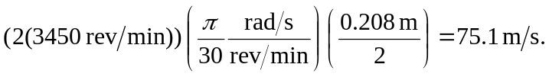
b) 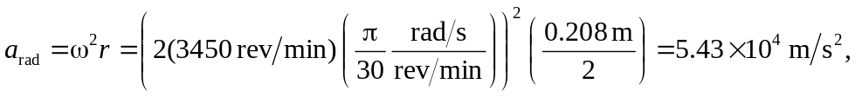
so the force holding sawdust on the blade would have to be about 5500 times as strong as gravity.

